BUSINESS INTELLIGENCE AND TOOLS
EXPERIMENT - 4

Aim: To perform Online Analytical Processing (OLAP) operations using Microsoft Power BI by creating multidimensional reports and applying Slice, Dice, Drill-up, and Drill-down operations on the Global Superstore dataset.

Step-wise Solution

PART A – LOAD DATASET

Step 1: Open Power BI Desktop

Step 2: Load the Global Superstore Dataset
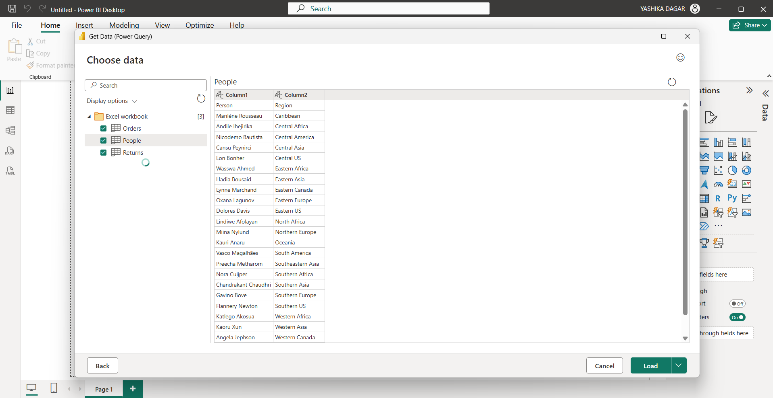

Step 3: Verify Table Relationships

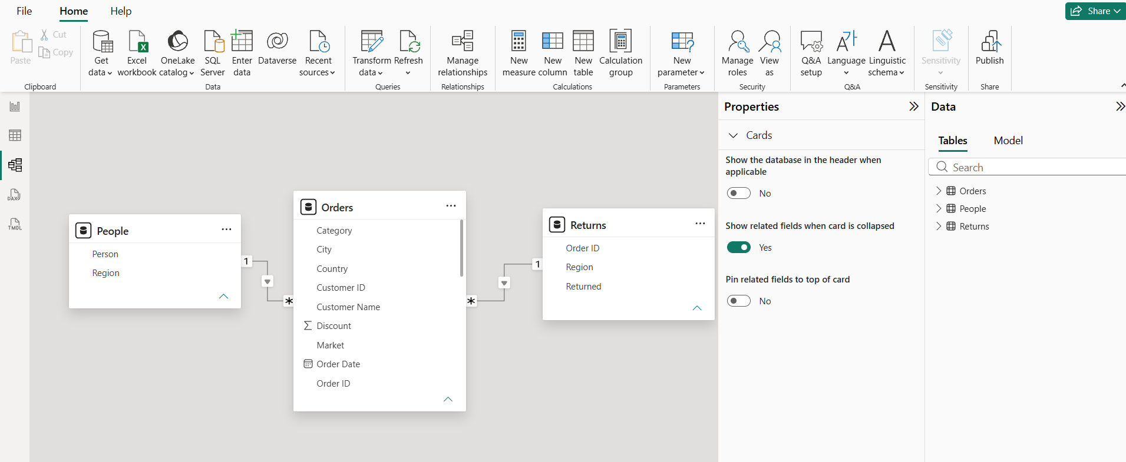

PART B: Create the following four visuals before performing the OLAP operations.

Step 4.1: Create Sales by Region
- Open Report View.
- Insert a suitable chart, such as a bar chart.
- Drag Region to the Axis field.
- Drag Sales to the Values field.
- Format the visual if required.
- Give the visual the title Sales by Region.
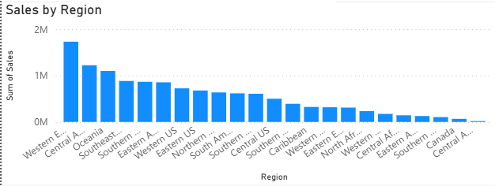

Step 4.2: Create Profit by Category
- Insert another suitable chart.
- Drag Category to the Axis field.
- Drag Profit to the Values field.
- Set the title as Profit by Category.
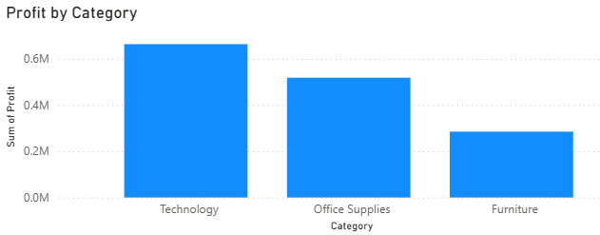

Step 4.3: Create Sales by Segment
- Insert a suitable chart.
- Drag Segment to the Axis field.
- Drag Sales to the Values field.
- Set the title as Sales by Segment.
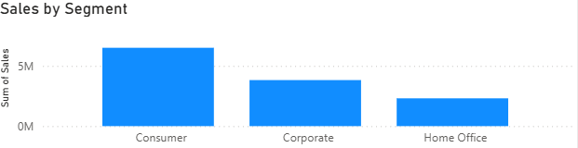

Step 4.4: Create Sales Trend by Year
- Insert a suitable line or column chart.
- Add the Year field to the Axis.
- Add Sales to the Values field.
- Set the title as Sales Trend by Year.

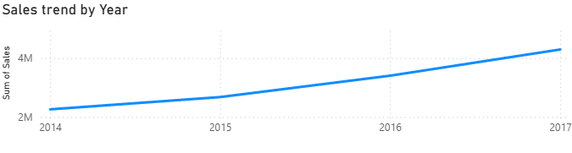

PART C – SLICE OPERATION

Step 5: Add a Region Slicer
- Click on an empty area of the report canvas.
- Select the Slicer visual.
- Drag the Region field into the slicer's Field area.
- The available regions will appear in the slicer.
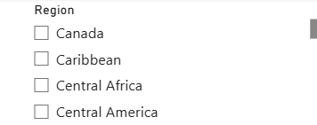

Step 6: Select One Region
- From the Region slicer, select West.
- Observe the other report visuals.
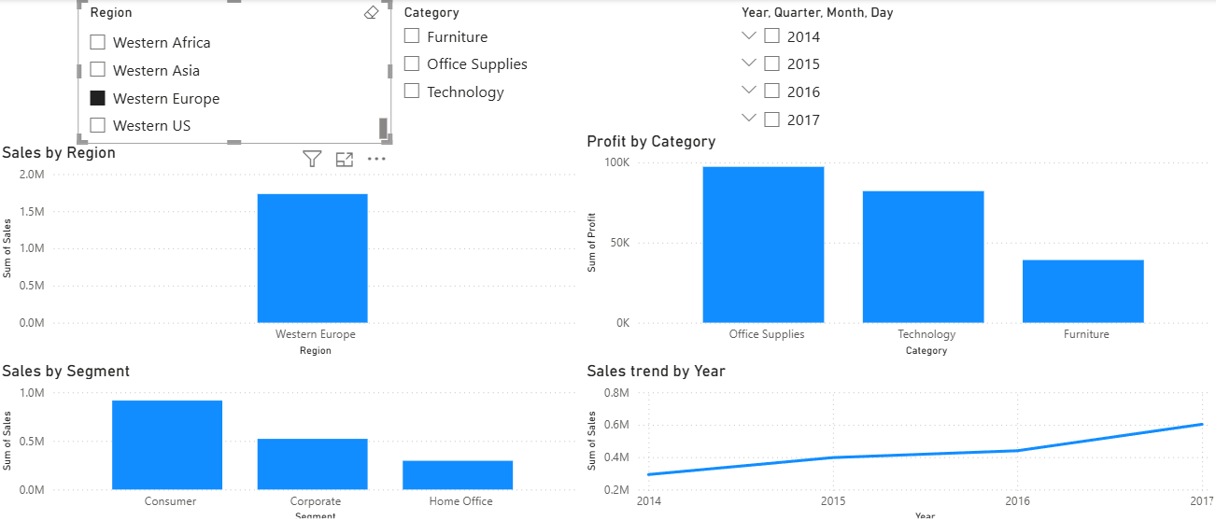
Step 7: Observe the Changes
Check the changes in:
- Sales
- Profit
- Orders
The other visuals should automatically respond to the selected region.

PART D – DICE OPERATION

Step 8: Apply Multiple Filters
Apply the following filters simultaneously:
- Region = West
- Category = Technology
- Year = 2017
You can use slicers or filters to apply these conditions.

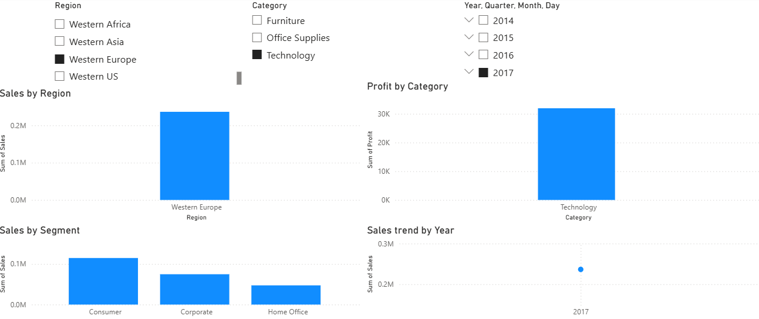

Step 9: Analyze Filtered Business Metrics
Observe the resulting:
- Sales
- Profit
- Orders
Record the values displayed by your Power BI report.

PART E – DRILL-DOWN OPERATION

Step 10: Create the Region–State–City Hierarchy
Create a geographical hierarchy containing:
Region → State → City
To create it:
- Go to the Data/Fields pane.
- Right-click the Region field.
- Select Create hierarchy.
- Add State to the hierarchy.
- Add City to the hierarchy.

Step 11: Create a Bar Chart Using the Hierarchy
- Insert a bar chart.
- Add the newly created Region–State–City hierarchy to the Axis.
- Add Sales to the Values field.
Expected Result:
The chart displays sales beginning at the Region level.

Step 12: Enable Drill-down
- Select the chart.
- Locate the Drill-down control in the visual header.
- Turn on Drill-down mode.
- Select a Region.
The chart will move from:
Region → State

Step 13: Continue to City Level
Continue drilling down from:
State → City
Expected Result:
The chart displays sales at the City level.
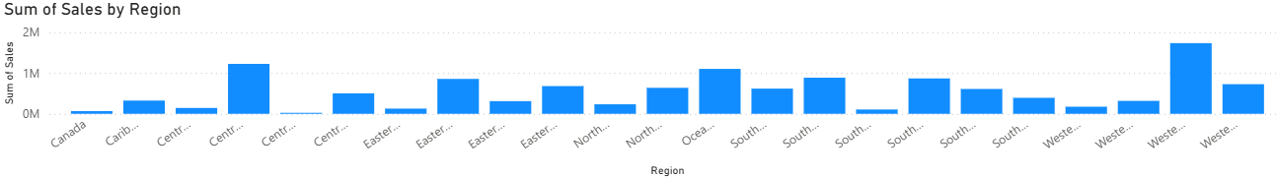
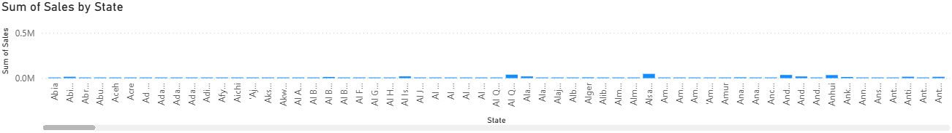
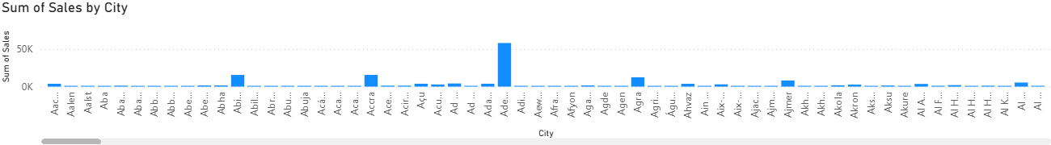
Observation:
Drill-down moves from summarized regional information to more detailed state and city information.

PART F – DRILL-UP OPERATION

Step 14: Navigate from City to State to Region
Starting from the City level, use the drill-up option to move upward through the hierarchy:
City → State → Region

Step 15: Compare Aggregated Values
Observe how the sales values change as the report moves from:
City → State → Region
At each higher level, the information becomes more summarized.

Step 16: Record the Observation
Observation:
The Drill-up operation moves from detailed information to higher-level aggregated information, making it easier to understand overall performance.

FINAL RESULT
